H2
ANDERSON JUNIOR COLLEGE
HIGHER 2

ANSWERS
CANDIDATE
NAME

PDG
INDEX NUMBER
PDG

BIOLOGY
9648/02
Paper 2 Core Paper 11 September 2012
2 hours

Additional Materials: Answer Paper

READ THESE INSTRUCTIONS FIRST
For Examiner’s Use
Section A | 80
1
2
3
4
5
6
7
Section B | 20
8 / 9
Total | 100

Write your name and PD group on all the work you hand in.
Write in dark blue or black pen.
You may use a soft pencil for any diagrams, graph or rough working.
Do not use paper clips, highlighters, glue or correction fluid.

Section A
Answer all questions.

Section B
Answer any one question.

All working for numerical answers must be shown.
At the end of the examination, fasten all your work securely together.
The number of marks is given in brackets [ ] at the end of each question or part question.

Calculators may be used

This document consists of 22 printed pages.

Section A
Answer all the questions in this section.

1 | Fig 1.1 shows the peptidoglycan cell wall of the prokaryote Escherichia coli.  The carbohydrate backbones are made up of two different kinds of sugar: N-acetylmuramate (NAM) and N-acetylglucosamine (NAG). NAM and NAG alternate along the chain and differ from glucose only at the C2 and C3 position.  Fig 1.2 shows the molecular structure of NAM and NAG.  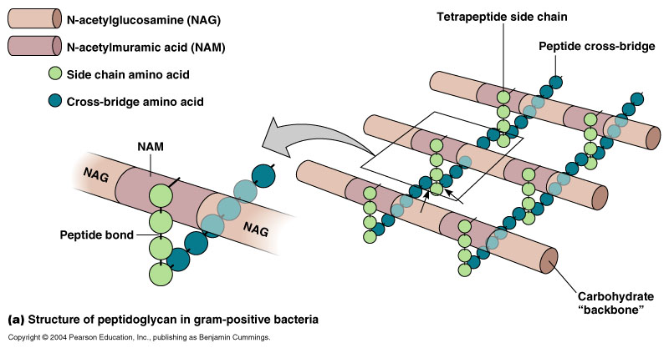  Fig. 1.1  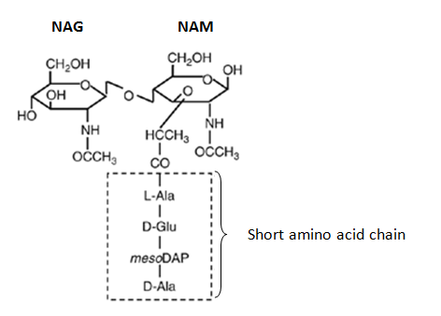  Fig. 1.2
(a) | With reference to Fig 1.1 and Fig. 1.2, describe two ways in which the structure of peptidoglycan:
 | (i) | is similar to cellulose.
 |  | - Both consist of beta (1,4) glycosidic bonds.  - Both consist of chains of polysaccharides lying parallel to one another.  - 180° rotation of alternating/neighboring subunits. |  | [2]
 | (ii) | differs from cellulose. |  | [2]
  Features | Peptidoglycan | Cellulose
  Cross-linking | Carbohydrate backbones crossed linked with short chains of amino acids/peptide cross bridges. | Cellulose molecule/chain (R: “cellulose”) crossed linked with hydrogen bonds
  Repeating units | Consists of repeating units of NAM and NAG | Consists of repeating units of beta-glucose.
(b) | The enzyme lysozyme is found in many pharmaceutical products like eye drop and throat lozenges that treat bacterial infection. Lysozyme is a glycoside hydrolase.  Suggest how the enzyme could be used to treat bacterial infection.
 | - Hydrolysis of the glycosidic bonds between the NAG and NAM.  - Diffusion of water into the cells/high osmotic pressure ruptures the cell wall |  |  | [2]
Fig 1.3 shows the synthesis of the structural protein collagen. Each collagen fibre is made up of numerous triple helix bundled together.

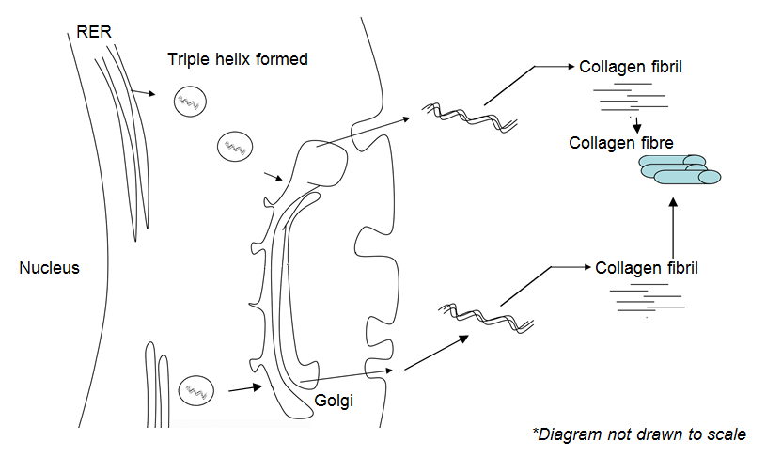

Fig. 1.3

(c) | With reference to Fig 1.3 and using your knowledge of the structure of collagen and protein synthesis, explain how collagen polypeptide chains first synthesized in the rough endoplasmic reticulum would be secreted out of the cell.
 | - Triple helix forms from 3 polypeptide chains, held via H bonds in the RER.  - Triple helix packed into transport vesicles and buds off the RER  - Move to golgi apparatus for further modification, sorting and packing into secretory vesicles.  - Vesicle fuses with plasma membrane, releasing collagen molecule via exocytosis. |  |  | [4]
(d) | Suggest why collagen fibre cannot be assembled within the cytoplasm.
 | - Too large to be packed into secretory vesicles. |  |  | [1]
(e) | Fig 1.4 is an electron micrograph showing collagen fibrils. The fibrils appear banded.  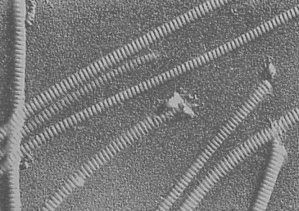  Fig. 1.4
 | Explain how the banded appearance of collagen fibrils contributes to the physical property of collagen.
 | - Banded appearance is due to staggered arrangement/longitudinal displacement of triple helix.  - Leads to high tensile strength. |  |  | [2]
[Total : 13]
2 | Fig 2.1 shows photomicrographs of an animal cell undergoing different stages of meiosis.  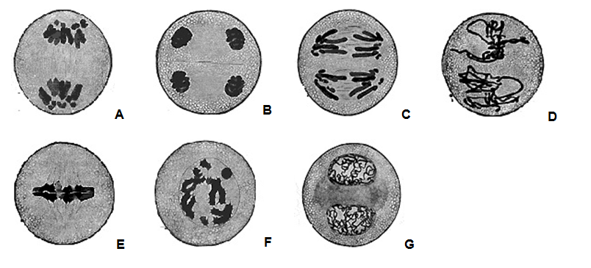  Fig. 2.1
(a) | With reference to Fig 2.1,
 | (i) | arrange the photomicrographs in successive stages of meiosis.
 |  | - F, E, A, G, D, C, B |  | [1]
 | (ii) | describe the events that occur at Stage C.
 |  | - Centromeres divide and each sister chromatid becomes a chromosome (R:split)  - Spindle fibre attached to the centromere at the kinetochore protein  - Spindle fibre shorten/Pulled by spindle fibre to the opposite poles of the cells. (R:ends)  (any 2) |  | [2]
(b) | Explain how the second division of meiosis differs from mitosis.
 | - In 2nd division of meiosis, two sister chromatids of each chromosome are not genetically identical to each other vs genetically identical sister chromatids in mitosis.  - Due to crossing over that occurs between homologous chromosomes during prophase I of meiosis. No crossing over occurs during prophase of mitosis. |  |  | [2]
(c) | The drug Vincristine could be used for the treatment of cancer by arresting mitotic cells at late prophase or early metaphase. It was found that Vincristine exerts its effect on tubulin molecules that make up the microtubules.  In an investigation to compare the effects of Vincristine and another drug Paclitaxel on tubulin molecules, purified tubulin molecules were introduced into a solvent in the absence (Control) and presence of Vincristine and Paclitaxel.  At the end of the investigation, the amount of microtubules formed was measured and the results are shown in Fig. 2.2.  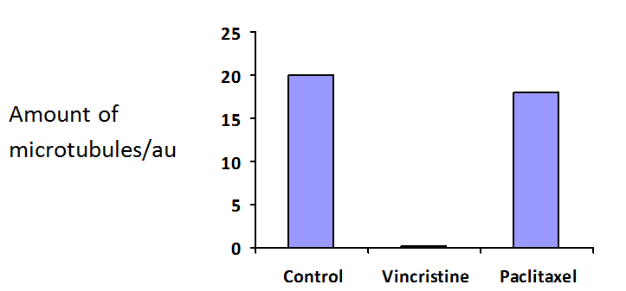  Amount of microtubules / a.u  Fig. 2.2
 | (i) | Explain why Vincristine could be used for treatment of cancer.
 |  | - Vincristine inhibits the polymerisation / formation of tubulins into microtubules, which attach to chromosomes  - Cell division/cycle cannot proceed and prevent uncontrolled / excessive cell division. |  | [2]
 | (ii) | With reference to Fig 2.2, explain which drug is more effective for cancer treatment.
 |  | • Vincristine  • In the presence of vincristine, no microtubules are present as compared to 18 au of microtubule in the presence of Paclitaxel |  | [2]
 | (iii) | Suggest a potential side effect of using Vincristine in cancer treatment.
 |  | - Prevent normal cells from undergoing cell division. |  | [1]
Cancer could arise due to errors that occur in DNA replication. One possible error is shown in Fig 2.3.

However, cells have mechanisms that are able to stop cell division, correct the error, before restarting the process again. This prevents the accumulation of genetic errors.

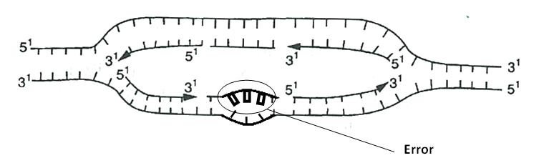
Fig. 2.3

(d) | With reference to Fig 2.3, explain how the error could be corrected.
 |  | - DNA repair enzymes remove mismatched/wrongly added nucleotides  - Add correct nucleotides based on complementary base pairing  (Reject Proof reading mechanism by DNA polymerase since daughter strand has already been formed) |  | [2]
 |  |  | [Total : 12]
3 | (a) | Explain why viruses are obligate parasites.
 |  | - lacks many of the enzymes and /or organelles necessary for protein synthesis/ ATP generation / metabolism / DNA replication  Parasites  - takes over/ takes control/hijacks host cell metabolic machinery for the production of progeny viruses→ disrupt host cell activities / may cause death of cell upon release of progeny |  | [2]
Fig. 3.1 is an electron micrograph showing two human immunodeficiency virus (HIV).
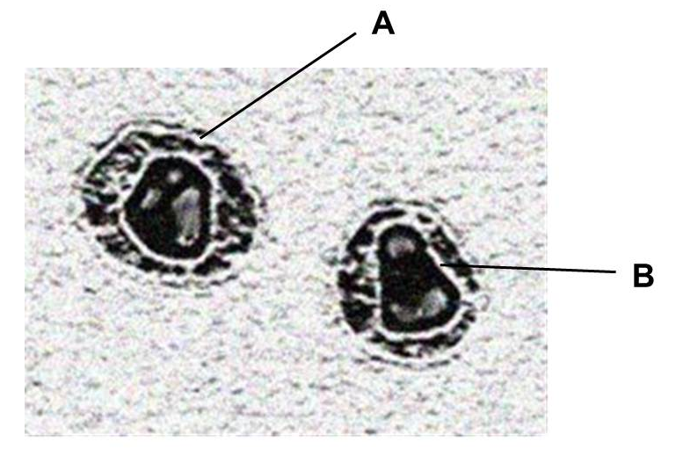

Fig. 3.1
(b) | Identify the structures labeled A and B
 | A: (viral) envelope  B: capsid |  |  | [1]
(c) | Fig. 3.2 shows the changes in HIV proteins concentration and CD4 T-cells count in the bloodstream of an individual after HIV infection.  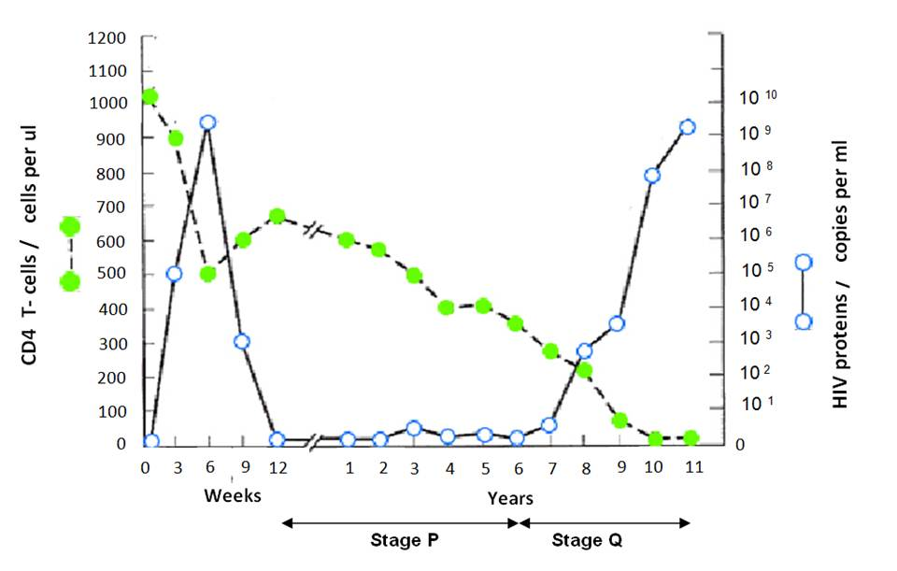  Fig. 3.2
 | (i) | Many cells in Stage P were found to contain viral DNA. Explain the significance of Stage P.
 |  | - Double stranded DNA reverse transcribed from the viral RNA integrates into the host cell DNA  - So that the viral DNA (encoding viral proteins) can replicate along/ together with the host cell DNA  - Idea of results in production of more cells that carries the viral DNA ( hence more viral progeny can be produced upon activation of the host cells) |  | [3]
 | (ii) | In an experiment, it was found that the concentration of the enzyme, histone deacetylase (HDAC) in infected cells at Stage P was higher than in infected cells not at Stage P.  Suggest an explanation for the presence of abnormally high levels of HDAC in infected cells at Stage P.
 |  | - Histone deacetylase cause chromatin to be more condensed / compacted/ packed more tighter  - Prevents transcription and translation of viral proteins during stage P  - Viral proteins not present on infected cells → not detected and destroyed by immune system  (any 2) |  | [2]
 | (iii) | With reference to Fig. 3.2, describe and explain the changes in the amount of HIV proteins and CD4 T-cells count during Stage Q.
 |  | - From 6 to 11 years after infection, [viral proteins] increases from 0 to 10⁹/10¹⁰ copies per ml because viral proteins are actively transcribed from integrated HIV DNA/provirus to form new viruses  - [CD4 T cells ] decrease from 350 cells per ul to 0 cells per ul as budding of large amount of virions from the cell surface of CD4 T cells may disrupt the cell membrane sufficiently for cell to die / Hijacking of cellular machinery and resources towards producing new virions disrupts normal activities needed for cell survival, eventually causing cell death. |  | [2]
Figure 3.3 is a phylogenetic tree showing the evolutionary relationships between a form of HIV, HIV-1, and the retrovirus, Simian immunodeficiency virus, SIV that afflict non-human primates. The phylogenetic tree was constructed based on molecular techniques.
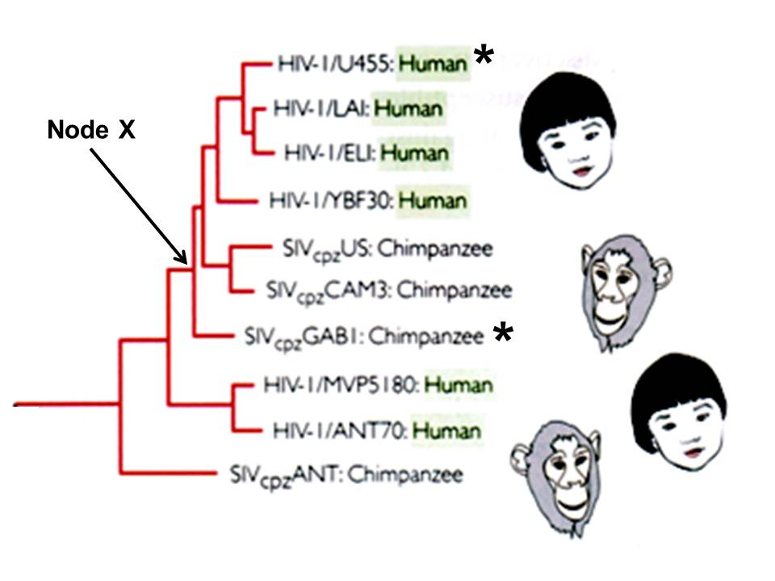

Fig. 3.3
(d) | State
 | (i) | the name of a gene which scientists used to construct the above phylogenetic tree.
 |  | - reverse transcriptase/ integrase / protease  ( Reject gp120/ gp41) |  | [1]
 | (ii) | the relationship between Node X, HIV-1/ U455: Human ( denoted with *) and SIVcpz GABI: Chimpanzee (denoted with *)
 |  | - node X is the most recent common ancestor which HIV-IU455: human and SIVcpz ANT:Chimpanzee diverge from/ share |  | [1]
(e) | Suggest why fossil records, normally used as evidence to study evolutionary relationships were inappropriate in the construction of this phylogenetic tree
 | - viruses are too small / too simple/ no cellular structures to form fossils  OR  - HIV and SIV only emerged recently, no fossil records yet  Note: during the formation of fossils, organic matter is gradually substituted by mineral crystals. |  |  | [1]
 |  | [Total : 13]
4 | Control of gene expression functions in a wide range of developmental processes including sex determination.  In Drosophila melanogaster the doublesex (dsx) protein is crucial in the development of sexual phenotype. In males, the presence of dsx-m activates the transcription of genes which products control male sexual development while the presence of its isomer, dsx-f in females represses the transcription of genes whose products control male sexual development.  Fig. 4.1 shows the structure of the dsx-m protein which has a DNA-binding domain and protein binding domain.  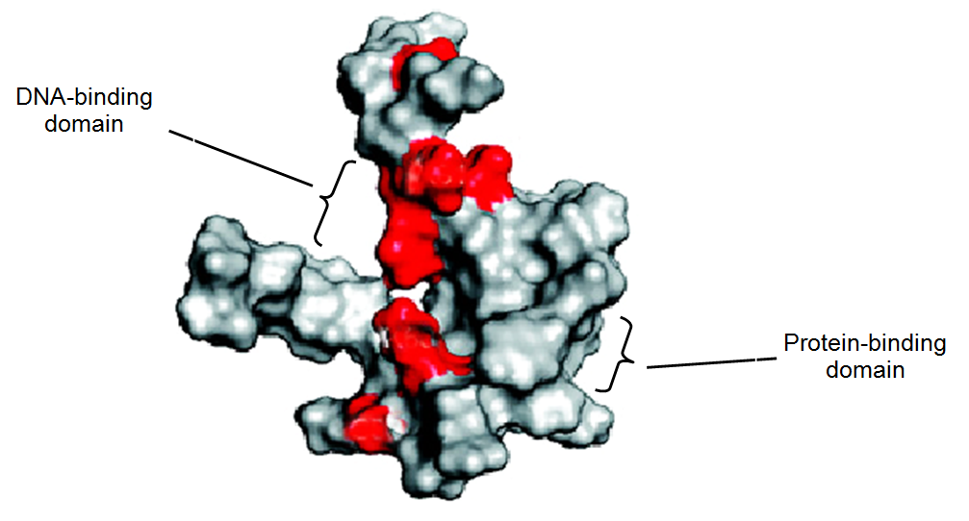  Fig. 4.1
(a) | (i) | State the general name given to proteins like dsx-m and dsx-f.
 |  | - (specific) transcription factors  Reject general transcription factors / activators and repressors |  | [1]
 | (ii) | Explain why the dsx-m protein contains both a DNA-binding domain and a protein-binding domain.
 |  | - DNA-binding domain binds to specific DNA sequences/ nucleotide sequences that make up enhancer  - Protein-binding domain binds to other transcription factors / RNA polymerase  - To enhance / Inhibit the formation of the transcription initiation complex → increase transcription |  | [3]
(b) | It was found that male Drosophila flies showing female characteristics mostly have an amino acid substitution at the DNA-binding domain of the dsx-m protein.  The shaded areas in Fig. 4.1 show the positions of amino acid substitutions presumed to affect the DNA-binding domain.
 | (i) | Explain why an amino acid substitution within the DNA-binding domain can affect the function of the dsx-m protein.
 |  | Effects of the substitution  - The amino acid substituted has a different R group with different properties /size/ charge  - affects R group interactions between the amino acids that form the DNA-binding domain  How function is affected  - tertiary structure/ 3D conformation of DNA-binding domain no longer complementary to shape of specific DNA sequences/ nucleotides that form enhancer |  | [3]
 | (ii) | Suggest why amino acid substitutions that occur outside of the DNA–binding domain can also affect the function of the dsx-m protein.
 |  | - these amino acids maintain the globular shape/ 3D shape / configuration / conformation of the proteins  - idea of when the globular shape/ 3D shape / configuration / conformation of the protein change, the shape of the DNA-binding domain also change  (students should draw idea from the mechanism of non-competitive inhibitor where binding of the inhibitor to allosteric site changes the globular shape of the enzymes, which also affects the shape of the active site) |  | [2]
(c) | While control of transcription is important in Drosophila sex determination, the nematode worm, Caenorhabditis elegans (C. elegans) depends on translational control of two important genes, Tra2 and Fem3 to determine sex.  Most C. elegans are hermaphroditic (have reproductive organs of both sexes), producing both  sperm and eggs at different times. When expressed, Tra2 promotes the development of eggs and  Fem3 promotes the development of sperm.  Fig. 4.2 shows the translational control of Tra2 and Fem3.  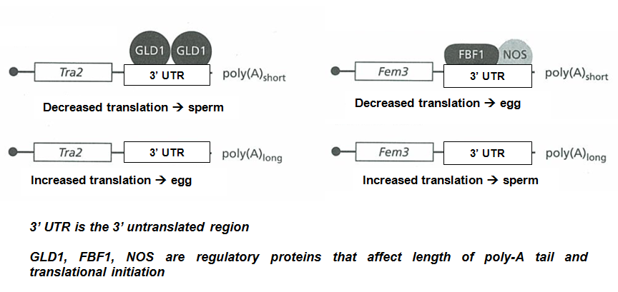  Fig. 4.2
 | (i) | State in which cell type of the C. elegans does translational control of Tra2 and Fem3 occurs.
 |  | - Germ line cells (Reject : Gametes) |  | [1]
 | (ii) | Describe and explain the effect of length of poly-A tail on gene expression.
 |  | Describe  - A longer poly-A tail allows increased translation → more proteins synthesized  ( reject more expression)  Explain  - Longer poly-A tail, longer time taken for poly-A tail to be shortened before mRNA degradation occurs  Accept converse argument |  | [2]
 | (iii) | Suggest the role of regulatory proteins such as GLD1, FBF1 and NOS in controlling gene expression.
 |  | - Idea of preventing formation of the translation initiation complex  Initiation of translation is thought to involve the formation of a closed loop between the 5’and 3’ ends of the mRNA (Sachs 2000) . GLD-1 prevents the formation of the loop  - Idea of recruits proteins/ enzymes that cause removal of poly-A tail  - recruits proteins/ enzymes prevent cytoplasmic poly-A tail addition  FBF-1 are PUF proteins that are involved in recruitment of the CCR4–POP2–NOT deadenylase complex for poly(A) tail removal.  - prevents binding of proteins that transport mRNA out of nucleus to cytoplasm  (Reject binding of regulatory proteins results in short poly-A tail) |  | [1]
 |  | [Total: 13]
5 | Different pure-bred lines of chickens show pronounced differences in mortality following infection with equal doses of two different strains of the bacterium Salmonella typhimurium.  In an investigation into the inheritance of resistance, a series of crosses was performed between two pure-bred lines of White Leghorn chickens, one line resistant to infection by the bacterium and one susceptible. The results of infecting newly hatched chicks of each purebred line, and of the cross between a susceptible male and a resistant female, are shown in Table 5.1.  Table 5.1  Infecting the F1 offspring with either the F98 or Swindon strain results in the same conclusion drawn about the inheritance of resistance to S.typhimurium .  It is thought that resistance to S.typhimurium is controlled by a single gene.
  line of chickens | mortality / % chicks infected
  line of chickens | strain of S. typhimurium
  line of chickens | F98 | Swindon
  resistant | 40.0 | 0.0
  susceptible | 100.0 | 35.7
  F1 offspring from cross between susceptible male and resistant female | 45.0 | 0.0
(a) | (i) | Using suitable symbols, draw a genetic diagram to show how resistance to S.typhimurium could be inherited in the cross as shown in Table 5.1.  - Symbols;  - Parental genotype and phenotype;  - Gametes (circled);  - F1 genotype and phenotype; |  | [4]
 | (ii) | Suggest why the resistance of the chicks to the two different strains of S.typhimurium shown in Table 5.1 is different.
 |  | - Allele codes for a protein that is effective against Swindon strain of bacterium but not effective against F98 strain; |  | [1]
(b) | When 20 chicks from crossing a susceptible male and a resistant female were infected with equal doses of strain F98 of S. typhimurium, 9 died, but when 19 chicks from the reciprocal cross of a resistant male and a susceptible female were infected with equal doses of the same strain of bacterium, only 3 died. In both cases, 40% of the chicks were expected to die.
 | (i) | State two reasons why the observed results of such crosses may be different from the expected results.  - Small sample size;  - Chicks may have died due to other reasons; |  | [2]
 | (ii) | Use the chi-squared test and the table of probabilities shown in Table 5.2 to find the probability of the results of the reciprocal cross described above (resistant male and susceptible female) differing from the expected results due to chance alone.  Show your working.  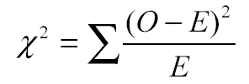  Table 5.2  - Calculation by formula;  - Probability between 0.02 to 0.05;  Probability: ………………………….. |  | [2]
  degrees of freedom | probability, p
  degrees of freedom | 0.10 | 0.05 | 0.02 | 0.01 | 0.001
  1 | 2.71 | 3.84 | 5.41 | 6.64 | 10.83
  2 | 4.61 | 5.99 | 7.82 | 9.21 | 13.82
  3 | 6.25 | 7.82 | 9.84 | 11.35 | 16.27
  4 | 7.78 | 9.49 | 11.67 | 13.28 | 18.47
 | (iii) | State the conclusion that can be drawn from your calculation of χ² value.  - At p=0.05, the calculated χ² value of 4.6 is more than the critical value of 3.84 / the probability that the difference between the observed and expected results is due to chance is less than 0.05 / 5%.  - There is a significant difference between the observed and expected results |  | [2]
 | [Total: 11]
6 | A comparative study on insect mouthparts is used to provide evidence for evolution. Table. 6.1 shows the structure of the mouthparts of various insects and their functions.  Insect mouthparts consist of:  - a pair of maxillae (upper jawbone) mx  - a pair of mandibles (lower jawbone), md  - a labrum (upper lip), lr  - and a labium (lower lip) lb  Table 6.1
  Insect | Structure of mouthparts |  | Function
  Butterfly | 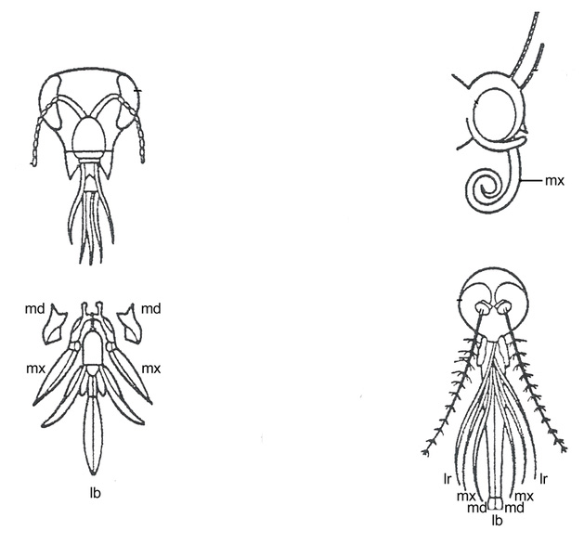 | Maxillae (mx) are long, forming sucking tubes  Mandibles (md) are lost  Labrum (lr) is reduced  Labium (lb) is reduced | Sucking
  Honey bee |  | Mandibles (md) are used to chew pollen and mould wax  Labium (lb) is long to lap up nectar | Licking and biting
  Female mosquito |  | Mandibles (md) form piercing stylets  Maxillae (mx) and labrum (lr) form sucking tube  Labium (lb) is grooved to hold other parts | Piercing and sucking
(a) | (i) | What is the term used to describe the relationship between structures such as those shown in Table 6.1?  - Homologous structures / homology |  | [1]
 | (ii) | Explain how the relationship between different insect mouthparts provides evidence to support the theory of evolution.  - Mouthparts have the similar structure / arrangement though they have different functions / describe sucking, licking , biting, piercing  - organisms once share/ structures originated from a common ancestor  - the different groups of insects are subjected to different selection pressure  - different structures are selected for / selected against  - structures are modified due to adaptation to different environments  (any 3) |  | [3]
(b) | Suggest how natural selection could have brought about the evolution in the length of mandibles in female mosquitos.  - Genetic variation/ different alleles encoding mandibles length results in different length of the mandibles  - At a particular selection pressure, mandible of a certain length is at a selective advantage/selected for  - Female mosquito with this mandible length survive and reproduce to pass down alleles encoding the particular mandible length to the offspring/ next generation  - Over time, increase in frequency of alleles encoding for the particular mandible length |  |  | [4]
 |  |  | [Total : 8]
7 | Fig. 7.1 shows the sequence of events in the glucagon signaling pathway in a hepatocyte.  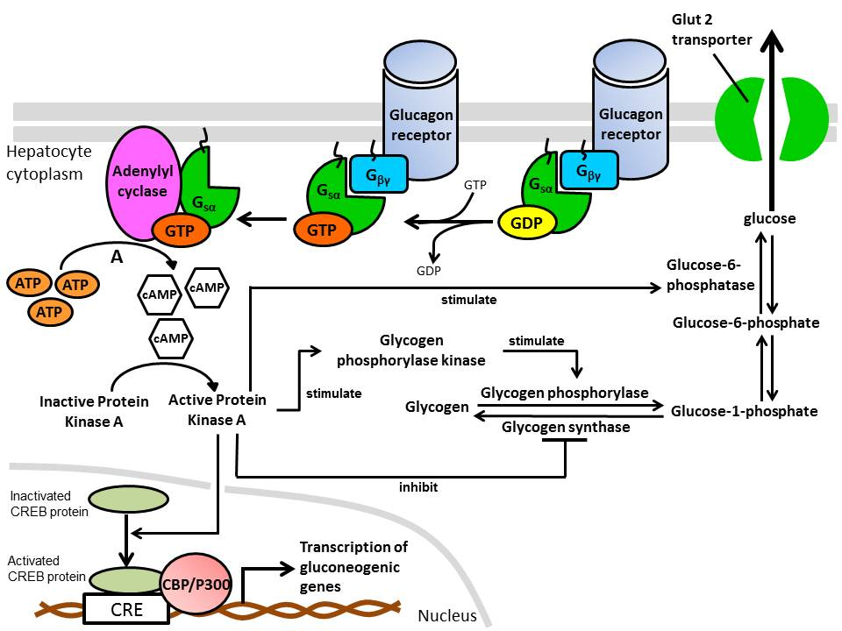  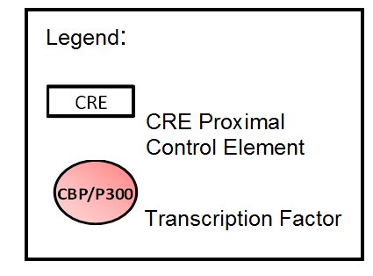  Fig. 7.1  Stage A
(a) | (i) | Describe how the binding of G_{sα} subunit would activate adenylyl cyclase.  - Binding of G_{sα} results in structural shape / 3D conformation change of Adenylyl cyclase protein;  - Active site of Adenylyl cyclase available to catalyse the formation of cAMP from ATP; |  | [2]
 | (ii) | Explain how Stage A shows signal amplification.  - One molecule of Adenylyl cyclase can produce many molecules of cAMP; |  | [1]
 | (iii) | Explain how activation of Protein Kinase A leads to increase in blood glucose concentration.  Any 3  - PKA activation stimulates glycogen phosphorylase kinase which in turn activate glycogen phosphorylase by phosphorylation  - Activated glycogen phosphorylase catalyse breakdown of glycogen to glucose-1-phosphate;  - PKA inhibit glycogen synthase, reducing / inhibiting the synthesis of glycogen from glucose-1-phosphate;  - Activate CREB protein which binds to CRE control element with CBP/P300 transcription factor increase in gluconeogenic gene transcription to increase gluconeogenesis;  - Stimulate glucose-6-phosphotase to produce more glucose from glucose-6-phosphate;  and  Glucose diffuses through Glut 2 transporter from hepatocyte cytoplasm into the blood; |  | [4]
(b) | Gluconeogenic genes code for proteins that are involved in the synthesis of glucose in cells.  With reference to Fig.7.1, state a gluconeogenic gene that will be transcribed due to the activation of CREB protein.  - Glucose-6-phosphatase; |  |  | [1]
(c) | When glucagon levels in the environment remain high for several hours, cells usually undergo desensitization, such that they no longer respond to that concentration of hormone. This prevents excessive and prolonged receptor activity.  Suggest how cells can decrease the stimulation of receptor molecules by the presence of high concentration of ligands.  - Endocytosis (receptor mediated), reducing the number of available cell surface membrane receptors;  - Less ligands binding to receptors, less stimulation of cell signaling pathway; |  |  | [2]
 |  |  | [Total : 10]
Section B

Answer one question.
Write your answers on the separate answer paper provided.
Your answer should be illustrated by large, clearly labeled diagrams, where appropriate.
Your answers must be in continuous prose, where appropriate.
Your answers must be set out in section (a), (b) etc., as indicated in the question.
8 | (a) | Explain how genetic variation may be preserved in a natural population.  Diploidy  - in heterozygotes, recessive alleles not expressed/ effects of recessive alleles remains hidden/ masked in the presence of the dominant allele.  - Recessive alleles will not come under selection pressure.  Reject heterozygotes will not come under selection pressure  - Heterozygote survives, reproduce and pass on recessive allele to next generation/ offspring.  (max 2)  Heterozygote advantage  - Heterozygous (at particular gene loci) has a greater fitness than do dominant or recessive homozygotes.  - Heterozygotes are more likely to pass down their alleles to the next generation/ offspring  - natural selection is able to maintain two or more alleles at that locus  (max 2)  Frequency dependent selection  - survival and reproduction/ fitness of one phenotype declines if that phenotypic form becomes too common in the population.  - Helps to maintain the frequency of each phenotype at a relative constant frequency.  - Accept if concept is illustrated through examples  (max 2)  Neutral variation  Neutral alleles/ variation that arise due to changes / variation ( any one mechanism only) :  - that does not affect protein structures/function.  - in non-coding DNA.  - in coding region of DNA, but due to degeneracy of genetic code, same amino acid encoded.  - in coding region of DNA that may change amino acid, but do not occur on the essential regions of proteins/does not affect the R-group properties or R-group interactions.  - neutral alleles / variations will not come under selection pressure or does not confer selective advantage nor disadvantage hence will be passed to the next generation |  | [8]
 | (b) | Besides gene mutation, outline the ways in which bacteria acquire genetic variation |  | [8]
Transduction
- A bacteriophage injects its DNA into a bacterial cell.

- Ref to generalized transduction, which involved a lytic phage, the bacterium’s DNA is degraded by viral enzyme
OR
- Refer to specialised transduction, which involved a lysogenic/temperate phage, prophage genome is excised from the bacterial chromosome. Sometime, a small region of adjacent bacterial DNA would be excised together due to an error in the excision.
(Award marks either for generalized or specialised transduction only)
- A small piece of bacteria DNA was incorporated into the phage capsid during viral assembly stage in the bacteria
- transducing phages infect other bacteria

- Foreign DNA containing donor bacterial DNA integrates into recipient chromosome via homologous recombination
OR
- The entire prophage with the donor bacterial DNA can be integrated into the host chromosome.
(Award marks either for homologous recombination when discussing generalized transduction or prophage integration when discussing specialised transduction)
(Max 4)
Conjugation
- Bacteria cells come into (temporary, physical) contact via conjugation tube/mating bridge , allowing transfer of F plasmids from donor to recipient cell.

- Recipient cells receive a double –stranded F- plasmid

Transformation
- Bacterial cells take up foreign DNA from the surrounding medium (via a cell surface receptor)

- Incorporating of foreign DNA into its own DNA via homologous recombination
 | (c) | Distinguish between gene mutation and chromosomal aberration. |  | [4]
Feature | Gene mutation | Chromosomal mutation
Definition | Change in the DNA base/nucleotide sequence | Change in the structure (several gene loci affected) or number of chromosomes
Mechanism | Brought about by insertion, deletion, substitution or inversion (of one or several nucleotides)  Give at least 2 examples | Brought about by duplication, deletion, translocation or inversion (of several gene loci) and non-disjunction  Give at least 2 examples
Results | Give rise to new alleles | Give rise to reshuffling of alleles
Frequency | More frequent than chromosomal mutations because genes outnumbered chromosomes | Less frequent than gene mutation
Evolutionary importance | Play a more important role in evolution than chromosomal mutations as new alleles increase gene pool for natural selection to operate | Play less important roles as chromosomal mutations involve mainly reshuffling of alleles that exists in the gene pool

9 | (a) | Describe, with named examples, the roles of membrane proteins in respiration and in the transmission of an action potential along an axon. |  | [8]
Respiration
- Electron carrier proteins in the inner mitochondria membrane (IMM) arranged from highest to lowest energy levels.
- Energy released as electrons are passed down ETC
- Hydrogen pumps in IMM uses the energy released to pump hydrogen ions
- from the mitochondrial matrix (through the inner mitochondrial membrane) into the intermembrane space to creates a proton gradient across the inner mitochondrial membrane.
- Hydrophilic channels in ATP synthase on IMM allows diffusion of H⁺ occurs from the intermembrane space back into the mitochondrial matrix.
- Enzymatic domain/ catalytic activity of ATP synthase catalyse the synthesis of ATP from ADP and P_{i}.
(Max 4)

Transmission of action potential
- Voltage gated Na⁺ channels - Allow entry of Na⁺ into axoplasm, down an electrochemical gradient, leads to depolarisation.
- Remains inactivated during repolarisation/hyperpolarisation/refractory period - > ensure one way transmission of nerve impulses.
- Voltage gated K+ channels - Efflux of K⁺ (diffuses along electrochemical gradient) causing repolarisation back to resting membrane potential
Maintenance of resting potential
- Presence of more ungated/open K+ channels than Na+ channels allow more K+ to diffuse out than Na+ in
- Sodium-potassium pumps actively transports 3 Na+ out for every 2 K+ in
(Max 4)

 | (b) | Explain how temporal and spatial summation lead to nerve impulse transmission at the postsynaptic neurone.  - Temperal summation: due to repeated simulation of the post-synaptic neurone at high frequency  - Spatial summation: ESPS produced nearly simultaneously by different pre-synaptic neurones for spatial summation.  - Two EPSP occur so close in time that post-synaptic membrane has not returned to RP before the arrival of the second EPSP / first stimulus may release small amount of neurotransmitters followed by another stimulus release more neurotransmitters before the first batch of neurotransmitters are destroyed  - EPSP adds together in the post-synaptic neurone to reach threshold potential to trigger action potential on the postsynaptic membrane. |  | [4]
 | (c) | Outline how glyceraldehyde 3-phosphate is made in the Calvin cycle and converted into starch and discuss the suitability of starch as a plant storage compound.  How glyceraldehyde 3-phosphate is made in the Calvin cycle  - Requires one ATP and one NADPH per G3P formed.  - Each CO₂ is attached/fixed to ribulose bisphosphate (RuBP) to form 2 molecule of glycerate-3-phosphate (GP).  - Reaction is catalysed by ribulose bisphosphate carboxylase/Rubisco.  - GP phosphorylated to form glycerate bisphosphate /1, 3-bisphosphoglycerate (BPG)  by phosphorylase.  - Carboxyl group reduced to aldehyde group by a pair of electrons, forming glyceraldehyde-3-phosphate (G3P)  (Max 4)  How G3P converted into starch  - Two molecules of G3P formed one molecule of α-glucose  - Glucose joined by α(1, 4) and α (1, 6) glycosidic bond  - during condensation reaction to formed starch (with amylose and amylopectin)  (Max 2)  Suitability of starch as a plant storage material  - Coiled into helices - > compact structure/take up little space.  - Individual chains (amylose molecules) not cross linked - > can be easily hydrolysed  - Large - > starch prevented from diffusing out/exert no osmotic influences  (Max 2) |  | [8]

Legend:

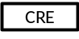 CRE Proximal Control Element
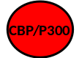Transcription Factor

Legend:

CRE Proximal Control Element
Transcription Factor

